GREEN RFP SUBMISSION FORM

Part I- General Information:
Name of Student Organization |  | Virginia Tech Triathlon Club
Contact/Responsible Person |  | Samantha McKinnon
Contact Office Held/Title |  | Member
Contact Email Address |  | smmckinnon@vt.edu
Contact Telephone Number |  | 571-288-8484
Part II- Project Cost Information
Estimated Cost of this Proposal |  | $63,000 | See III.C. below
Estimated Savings - |  |  | See III.D. below
Net Cost of this Proposal = |  | $63,000
Part III- Supporting Information

- Please describe your climate action, sustainability, and/or energy initiative and attach supporting documentation.
Our sustainability initiative focuses on promoting the utilization of alternative transportation on campus. With roughly two thirds of the student population now living off-campus, we aim to alleviate the strain on Blacksburg Transit, which already has a steady state of high capacity buses. We also aim to reduce parking demand by providing an alternative to driving to (and parking on) campus. Especially with the current construction projects of Hitt Hall and the Blacksburg Transit Multi Modal Transit Facility (MMTF) causing the relocation of the bike racks near the New Classroom Building, we want to add a secure bicycle parking facility inside the Perry Street Garage.
The facility will provide greater security and better protection from the elements, which has been shown to increase the likelihood of someone bicycling to their destination. Access will be restricted to university affiliates who purchase a secure bicycle parking permit. There will be showers, restrooms, water fountains, and the Hokie Bike Hub in the MMTF building. That combined with the fact that this facility would be central to the academic core and the MMTF’s bus loops makes this location ideal for a secure bicycle parking facility. This location already has security cameras nearby, and a minor adjustment to one of them could make this space even more secure. The following images show what this space could look like.

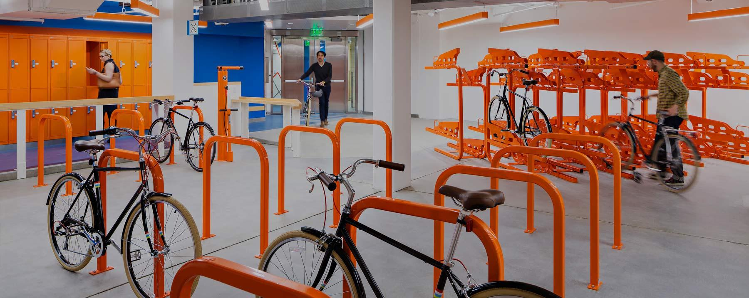
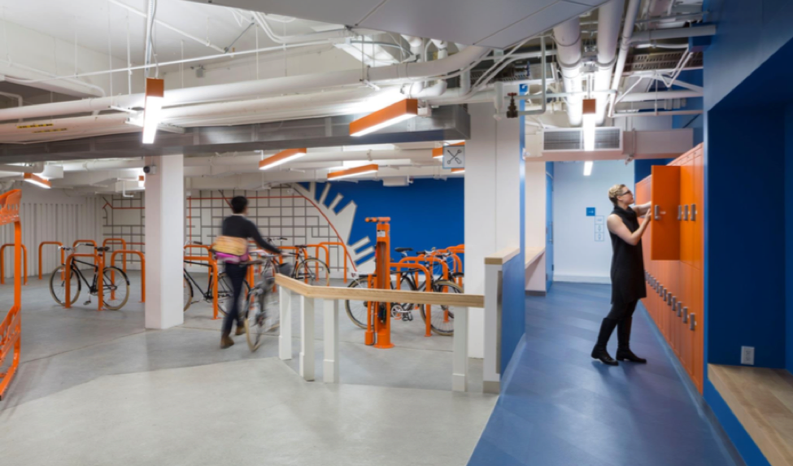
Photos courtesy of Dero

We propose converting a space of five parking spots inside the Perry Street Garage next to the Hokie Bike Hub (see picture below) into what we’re calling the MMTF Bicycle Commuter Center. We want to add seven bike racks, with a total capacity of 72 bikes. A bike Fix-It Station and lockers will give bicyclists a place to perform minor maintenance and repairs, and store their gear while they’re not riding. A couple electrical outlets will give people with electric assist bikes an opportunity to charge their batteries. These bike-friendly amenities will also help drive demand for the space.

This location is advantageous because it is central to the academic core and the MMTF. Additionally, this is a covered site, which supports the Bicycle Parking Master Plan’s requirements for covered bicycle parking. It also helps meet the bike rack capacity requirements at nearby buildings.

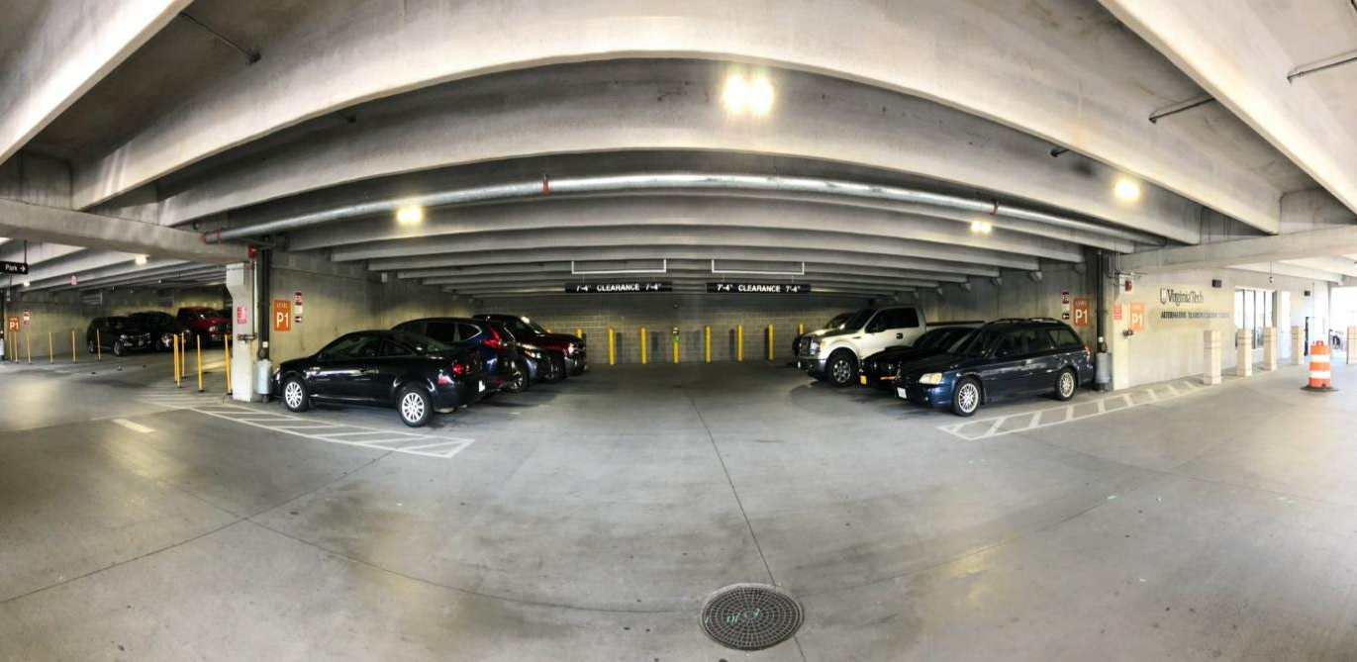
The location of the 5 parking spaces in Perry Street Parking Garage that will become the MMTF Bicycle Commuter Center. These spaces are located on the first floor, adjacent to the Alternative Transportation Department.

- How does this initiative help to achieve the goals of the Virginia Tech 2020 Climate Action Commitment Resolution and Sustainability Plan?
This initiative closely aligns with the Virginia Tech 2020 Climate Action Commitment Resolution and Sustainability Plan goals by reducing greenhouse gas emissions. The MMTF Bicycle Commuter Center will encourage people to bike to campus by providing greater security and better protection from the elements. It will also alleviate congestion and parking problems on campus.
Adding the MMTF Bicycle Commuter Center will show that Virginia Tech recognizes the importance of zero-emission transportation as an essential aspect of environmental sustainability. Biking is also economically sustainable, as commuters will not have to pay for fuel. Finally, it will help improve Virginia Tech’s status as a Bicycle Friendly University, a national program that “recognizes institutions of higher education for promoting and providing a more bikeable campus for students, staff, faculty, and visitors,” from silver to gold. Adding this space helps the university meet the requirement of changing stations, long-term storage, and covered racks.

- What is the cost of your proposal? Please describe in adequate detail the basis for your cost estimate.
We recommend adding three eight-loop and three six-loop bike racks to this space. The Dero Fix-It Station with the Air Kit 4 bike pump is the standard bike repair stand model used on campus. We propose four locker units with a total of 24 lockers, and a 6’ long bench for people to sit on to while putting on and removing gear. Fencing, two security cameras, and Hokie Passport access will make the space secure by controlling access. The $3,000 per parking space represents the cost capital projects are required to pay when they permanently remove parking.
Details for all costs associated with this project are included in the following table. All told, this proposal is estimated to cost $63,000.

ITEM DESCRIPTION | UNIT COST | INSTALL COST  (PER UNIT) | QUANTITY | TOTAL COST
6-loop bike rack | $1,900 | $150 | 3 | $6,150
8-loop bike rack | $2,500 | $150 | 3 | $7,950
Dero Fix-It Station | $2,250 | $250 | 1 | $2,500
Lockers | $650 | $150 | 4 | $3,200
Bench | $1000 | $150 | 1 | $1,150
Electrical outlets and wiring | $3,728 | - | - | $3,728
Fencing | $7,500 | - | - | $7,500
Hokie Passport access | $3,200 | - | - | $3,200
Security cameras | $2,600 |  |  | $2,600
Compensation to Parking Services for lost parking spaces | $3,000 | - | 5 | $15,000
Subtotal |  |  |  | $52,978
Contingency (~20%) |  |  |  | $10,022
Total |  |  |  | $63,000

- Will your proposal produce cost savings for the university? If so, how much? Please describe in adequate detail the basis for your savings estimate.
This proposal will not produce any cost savings for the university.

- Is this funding request for a one-time need or an ongoing need (please mark one)?

One-Time X Ongoing _____

- Is funding available for this request from another source? If yes, describe the funding (source, amount, etc.).
Funding is not available for this request from another source.

GREEN RFP SUBMISSION FORM
(Continued)

Part IV- Requestors/Reviewers
Samantha McKinnon  Prepared By (Name of Contact for Student Organization) |  | Date 11/19/2021
Nick Quint  Reviewed By (Name of Appropriate University Official)  Nathan King  Reviewed By (Name of Office of Climate Action, Sustainability, and Energy Representative) |  | 12/7/21  Date  12/3/21  Date

