STUDENT ORGANIZATION SUSTAINABILITY INITIATIVE PROPOSAL FORM

Part I- General Information:
Name of Student Organization |  | UAP 3354 - Introduction to EPP
Contact/Responsible Person |  | Nathan Orrick
Contact Office Held/Title
Contact Email Address |  | norrick@vt.edu
Contact Telephone Number |  | 7003-407-5496
Part II- Project Cost Information
Estimated Cost of this Proposal |  | $3000 | See III.C. below
Estimated Savings - |  | $137.16 annually | See III.D. below
Net Cost of this Proposal = |  | $2862.84
Part III- Supporting Information
A. Please describe your sustainability initiative and attach supporting documentation.

The focus of my sustainability initiative is to recycle rainwater to using for gardening and landscaping purposes at the Hahn Horticulture Garden. This would help offset the freshwater demand by utilizing rainwater as a sustainable alternative for the horticulture garden’s needs. A rainwater harvesting system could be installed alongside the Hahn Garden Pavilion to collect rainwater from the roof and make use of it rather than let it
become runoff. Instead of having Virginia Tech provide the Hahn Horticulture Garden with municipal water, greywater can be naturally provided for free in the form of rain. This would lower the university’s water and carbon footprint, and it allow Hahn Horticulture Garden to function more independently.

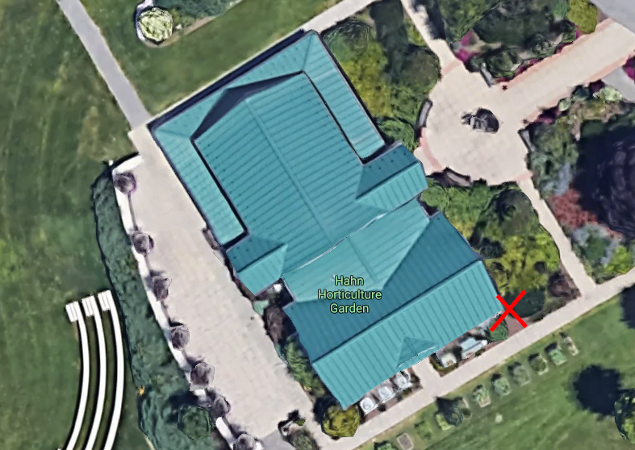
B. How does this initiative help to achieve the goals of the Virginia Tech Climate Action Commitment Resolution and Sustainability Plan?
Using a rainwater harvesting system requires much less energy than using water from the municipal water treatment plant. Instead of using water treated and pumped all the way from the plant, rainwater would be provided naturally and pumped on site at the garden.
Goal 12 of the Climate Action Commitment Resolution and Sustainability Plan involves making sustainable infrastructural changes. Installing the rainwater harvesting system would be sustainable, energy-efficient way to provide the garden with water.

C. What is the cost of your proposal? Please describe in adequate detail the basis for your cost estimate.

As for the supplies for our project, there needs to be one 500-gallon cistern, assorted hardware for assembly or extra cistern fittings, a hose, and leveling sand. The individual cost of each material is listed at the bottom of this proposal, additional hardware for assembly is estimated to be about $100, and the overall one-time cost is projected to be $475.09. There will be no labor costs because all labor will be student volunteers or facilities staff.

$2600 + $100 + $15 + $24 = $2,739 in one-time costs. + 10% contingency = $3,000
D. Will your proposal produce cost savings for the University? If so, how much? Please describe in adequate detail the basis for your savings estimate.

This project will pay for itself 16 years after installation, and then continue to generate savings annually in water use bills. Based on rainfall averages in Blacksburg and a rough estimate of the Peggy Lee Hahn Pavilion roof area, the rain cistern would collect and save 10,800 gallons of rain annually. Considering the University pays the town of Blacksburg $6.90 and $5.80 (total of $12.70) for water and sewage respectively for every 1,000 gallons of water, the University would be saving $137.16 annually, at current prices. There are also the unseen benefits due to education and relief of storm water infrastructure.

Estimated roof surface area for desired location = 400 ft² draining into cistern
average annual total rain/snowfall amounts = 43.5 in
43.5 in / 12 in = 3.6 ft * 400 ft² = 1,440 ft³ of rainfall collected by the cistern in a year
1,440 ft³ * 7.5 gal = 10,800 gal annually / 500 gal = 21.6 cisterns collected annually
10,800 / 1,000 = 10.8 * $12.70 = $137.16 annually
Savings after 2 years: $274.32
Savings after 5 years: $685.80
Savings after 10 years: $1371.60
Savings after 16 years: $2194.56

E. Is this funding request for a One-Time need or an Ongoing need (please check one)?
X One-time |  Ongoing
F. Is funding available for this request from another source? If yes, describe the funding (source, amount, etc.)

No.
STUDENT ORGANIZATION SUSTAINABILITY INITIATIVE PROPOSAL FORM
(Continued)

Part IV- Requestors/Reviewers
Nick Orrick  Prepared By (Name of Contact for Student Organization) |  |  | Date 11/17/21
Scott Douglas  Reviewed By (Name of Appropriate University Official)  Nathan King  Reviewed By (Name of Office of Energy and Sustainability Representative) |  |  | Date 12/7/21  12-3-21  Date

Examples
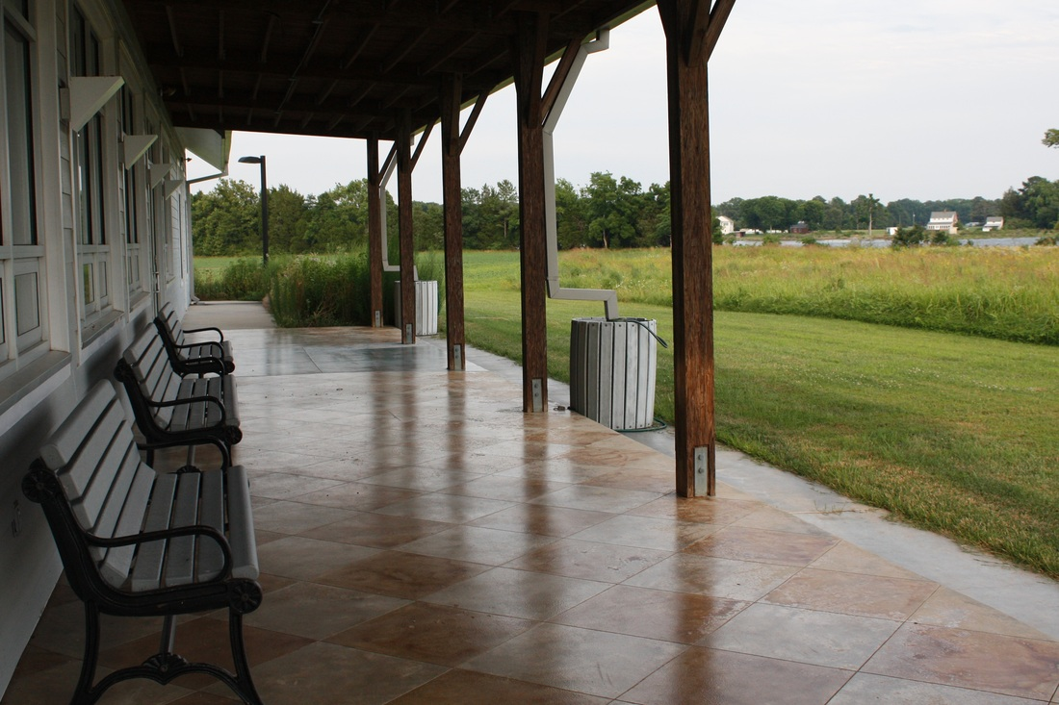

Rainwater barrels installed at the visitor center of Belle Isle State Park; used for inspiration

http://www.sassafrasfarmnatives.com/design-projects.html

Costs

⅝ in. diameter x 25 feet Heavy Duty Hose
https://www.homedepot.com/p/Neverkink-5-8-in-Dia-x-25-ft-Heavy-Duty-Water-Hose-8605-25/100661323
Price: $15.47

500-gallon Cistern
https://rainwatermanagement.com/collections/packages-designs/products/500-gallon-rainwater-kit
Price: $2060.00

Cubic Yard of Leveling Sand
https://www.homedepot.com/p/0-5-cu-ft-Leveling-Sand-98000/100343385
Price: $23.28

Additional Fittings and Materials
Price: $100
The addition of 100 dollars is cover additional miscellaneous materials during the construction of the project. Screws and other small construction materials add up in cost quickly, so we added this additional amount to cover unforeseen material needs.

